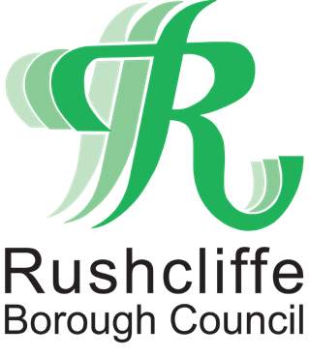

Rushcliffe Borough Council

People Strategy
2025 - 2028

Managing Change - Supporting People - Sustaining Excellence

Foreword from the Chief Executive

Rushcliffe Borough Council has always been defined by its people — committed, professional, and proud to serve our communities.

As we enter a time of significant change under Local Government Review (LGR), we face the reality that Rushcliffe Borough Council, as an organisation, will cease to exist within two years. Yet the spirit of Rushcliffe — our values, our standards, and our people — will continue.

This People Strategy sets out how we will support, develop, and care for our workforce through this transition. It focuses on sustaining service excellence, supporting wellbeing, developing and retaining key skills, and ensuring every colleague feels valued and prepared for the next chapter — whether within the new unitary authority or beyond.

Our goal is simple: to finish well, together, and to ensure the Rushcliffe legacy lives on through our people.



Adam Hill
Chief Executive, Rushcliffe Borough Council

Introduction and Context

Rushcliffe Borough Council has a strong reputation for innovation, partnership, and excellent service delivery. The LGR process, which will see the creation of new unitary governance arrangements across Nottinghamshire, means that Rushcliffe will formally transfer its responsibilities by 2027.

During this period, maintaining service quality in the most effective way, supporting our staff, and ensuring a smooth and positive transition are our priorities.

This strategy provides a framework to lead, engage, and develop our people through this time of change, focusing on stability, wellbeing, and legacy – all underpinned by our values.

Our employees are central to our achievements so far and we continue to need the best people working at Rushcliffe, working in a culture, environment and with the opportunities to achieve their best now and have the best opportunities in the new organisation.

Strategic Aims

- Sustain high-quality services throughout the transition.
- Support wellbeing and engagement through open communication and compassionate leadership.
- Retain and transfer critical talent and knowledge to the new local government structure.
- Prepare and develop staff for their next opportunities.
- Celebrate and embed the Rushcliffe legacy in the future arrangements for local government.

Our Values

As we transition, our core values become even more important and will continue to guide us.
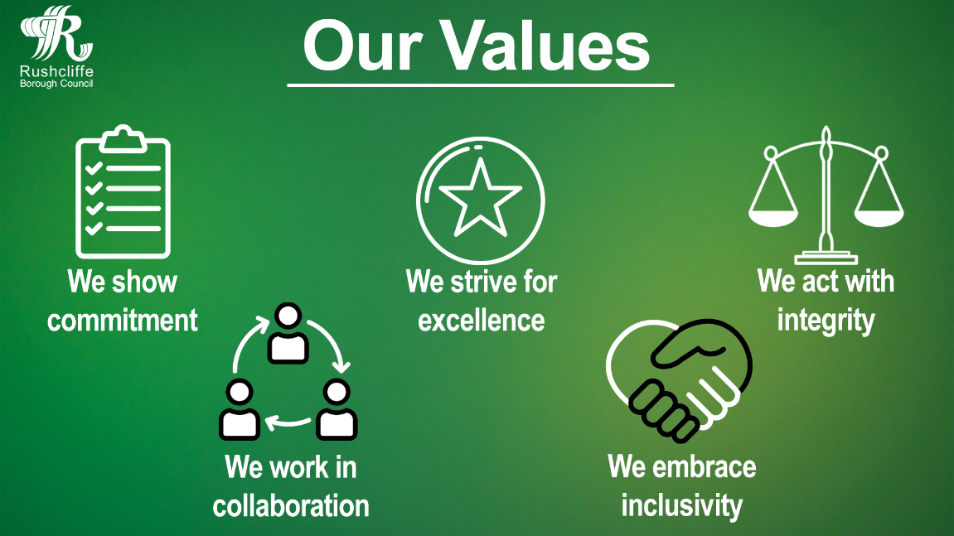

Strategic Priorities and Actions

To meet the Council’s strategic aims the following strands of the People Strategy will be our focus moving forward through the LGR process.

Leadership and Communication
- Transparent communication: Regular updates on LGR developments, timelines, and staffing implications.
- Visible and accessible leadership: Senior leaders to maintain a strong presence across teams.
- Empowered managers: Equip line managers with the skills, toolkits, resources, and confidence to effectively support employees through uncertainty and inspire teams.
- Staff engagement: Continue employee liaison group and forums, surveys, Chief Executive’s staff sessions and regular communications/feedback opportunities.

Workforce Planning, Attracting and Retaining the best people
- Succession Planning: Essential to map out critical roles in order to safeguard key posts required for service continuity and transition.
- Retention and motivation: Continue to review recognition and retention measures for employees.
- Structured Onboarding: to provide a warm introduction to our culture, values and ways of working, while offering practical support needed to thrive in their role.
- Resilience and Adaptability: Encourage continued collaboration and flexibility across teams to share capacity and maintain delivery.
- Knowledge capture: Implement structured knowledge transfer and succession planning to preserve Rushcliffe’s expertise.

Being Inclusive & Building Diversity

- Diversify the candidate pool: working in collaboration with other local authorities on the national recruitment drive to promote local government jobs and support opportunities for the local community.
- Monitoring: Understanding reasons and develop actions to address under-representation and pay gaps.
- Policy: Ensure equality, diversity and inclusion considerations as part of policy development and organisational design.
- Engagement: Involvement in national schemes and initiatives to support under-represented groups into work.
- Development: increasing awareness and understanding of EDI.

Employee Engagement and Wellbeing
- Wellbeing focus: Continue to promote physical, emotional, and financial wellbeing through existing programmes such as the EAP, Workplace Health Champs, Occupational Health and MHFA.
- Resilience and change management: Recognise emotional impact of change and provide access to coaching, resilience training, and mental health support.
- Work–life balance: Maintain flexible and hybrid working practices where appropriate and ensure capacity is available within teams to deliver the day job alongside the pressures of LGR.
- Supporting Employees: Encouraging and signposting employees to get the support they need in relation to areas such as disability, health conditions, those with caring responsibilities etc.
- Recognition and celebration: Mark milestones and achievements, ensuring staff feel valued throughout transition.
- Enjoyment at Work: Wellbeing and Social Club events, reduced gym membership, workplace health champion initiatives.
- Workload Management: proactive resource planning, clear prioritisation and open communication to ensure staff are not overwhelmed.

Skills, Learning, and Transition
- Career development: Offer workshops, mentoring, and one-to-one support for preparing CVs, job applications and interviews.
- Reskilling opportunities: Provide access to learning relevant to new council structures and emerging service models.
- Developing into the future: Invest in staff development, acting-up, secondment opportunities and project working. Identify and address skills gaps on working within a unitary.
- Digital service delivery: upskill staff in digital technologies and addressing digital exclusion.
- Apprenticeships and early careers: Continue to invest in development opportunities for people starting or changing careers.

Culture and Legacy
- Embedding our values: Uphold Rushcliffe’s standards of professionalism, innovation, and public service until our final day and beyond.
- Openness and Psychological Safety: committed to listening, responding constructively, and ensuring everyone feels heard and respected.
- Leadership legacy: Capture and share Rushcliffe’s leadership lessons for inclusion in future governance models.
- Celebrating our story: Record and share our organisational history and achievements through a legacy project.
- Collaborative transition: Work closely with Nottinghamshire partners, trade unions, and LGR programme boards to shape a positive future.
- “Leaving well” ethos: Support every employee to conclude their Rushcliffe journey with pride and dignity.

Governance and monitoring success

The People Strategy will be owned by the Chief Executive and the Directors, supported by Assistant Directors, HR and Managers throughout the organisation.

Quarterly progress reports will be presented to:
The LGR Transition Board
Executive Management Team
Employee Liaison Group
Staff Change Champions

An Implementation Plan will set out detailed actions, timelines, and responsible officers.

Progress will be measured through:

- Service performance indicators
- Outcomes and results from staff engagement surveys which should be more frequent throughout the LGR process
- Retention and turnover rates, as well as feedback from exit interviews
- Monitoring of sickness absence data specifically in relation to areas such as stress
- Uptake and feedback from wellbeing related activities
- Feedback from forums such as Change Champions, Employee Liaison Group and Transition Board

