Nottinghamshire Police and Crime Commissioner Election

Held on Thursday 2 May 2024

CERTIFICATE OF COUNT TOTALS
As the Local Returning Officer appointed for the voting area of RUSHCLIFFE at the election for the Police and Crime Commissioner for the Nottinghamshire Police Area held on Thursday 2 May 2024, I hereby certify that:
The total number of ballot papers verified is: |  |  |  | 34977
The total number of valid votes is: |  |  |  | 34269
Rejected Ballot Papers
Want of Official Mark |  |  | 0
Voting for more than one candidate |  |  | 8
Writing or mark by which the voter could be identified |  |  | 0
Unmarked |  |  | 521
Void for uncertainty |  |  | 178
The total number of rejected ballot papers is: |  |  | 707
The total number of valid votes cast for each of the candidates is as follows:
CANDIDATE |  | DESCRIPTION |  |  |  | VOTES
GODDEN, Gary Anthony |  | Labour and Co-operative Party |  |  |  | 15931
HENRY, Caroline Henry |  | Conservative Candidate – More Police, Safer Streets |  |  |  | 13580
WATTS, David Kenneth |  | Liberal Democrats |  |  |  | 4758
Signed: | 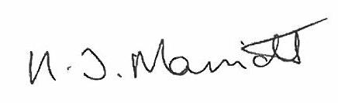
Name: | Kath Marriott
Local Returning Officer
Dated: | Friday 3 May 2024

