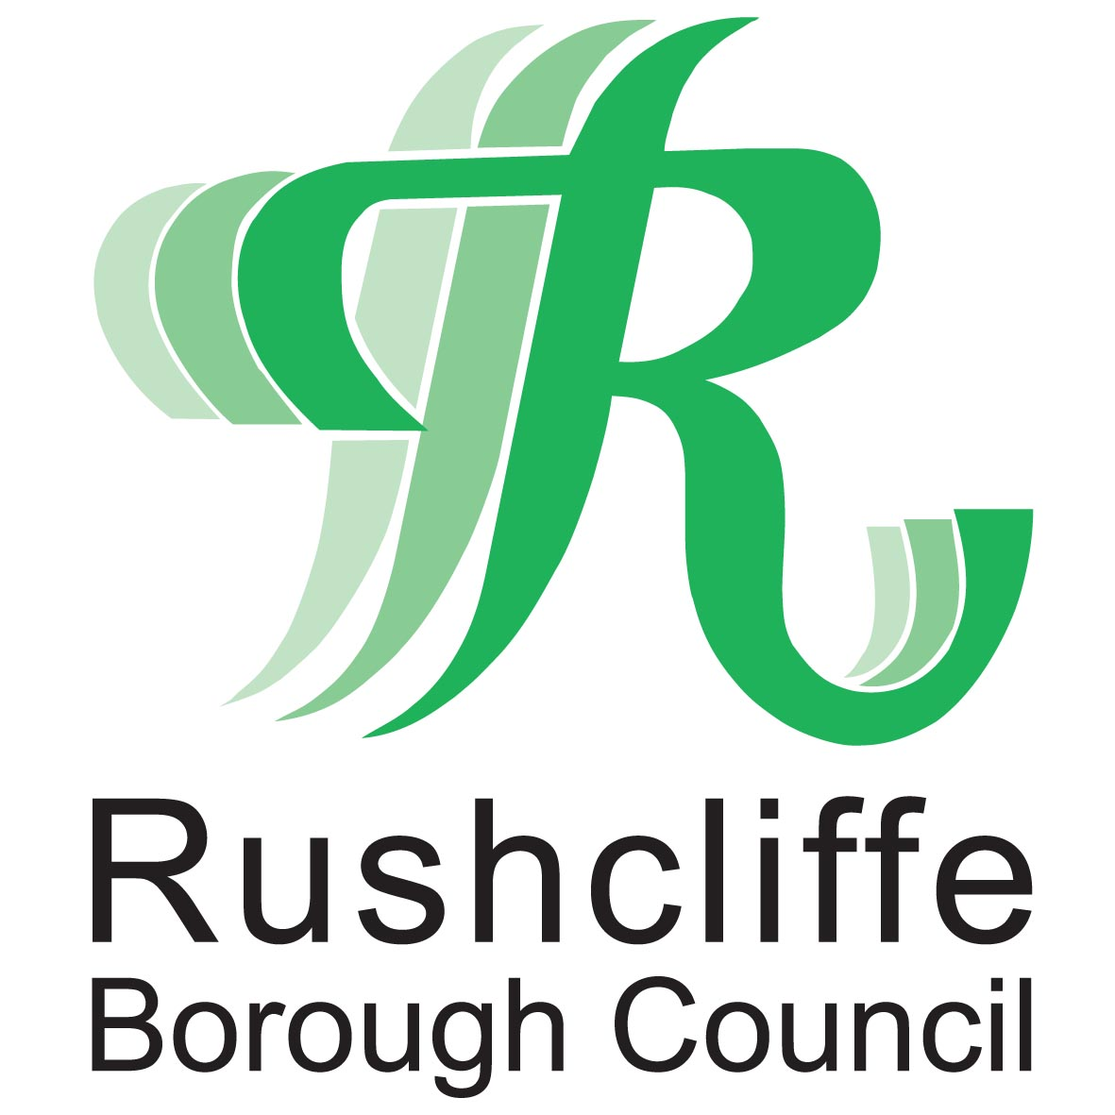
Rushcliffe Biodiversity Support Grant
Rushcliffe Biodiversity Support Grant
Biodiversity in Rushcliffe is supported by a wide range of individuals, organisations and businesses. The aim of this grant is to help continue this work.
The Grant
Grants are to help pay for specific expenses incurred in supporting biodiversity; each expense must be claimed within six months of when they are incurred, but please get approval first.
GRANTS CANNOT BE AWARDED RETROSPECTIVELY OR WHEN WORK IS REQUIRED AS A CONDITION OF PLANNING CONSENT.
Grants if approved will be paid between £100 and a maximum of £750.
Please do not start work / make your purchase until you have received confirmation that your grant has been approved.
Potential expenses could include:
- Tool purchases
- Training e.g. Wildlife survey or habitat management techniques
- Interpretation or publicity media
- Insurance costs
- Purchases of materials
- Site Works – e.g. habitat management or creation (including ponds and wetlands, hedgerows, woodland and grasslands) or access works
For Site Work, we will only pay 50% of the costs up to the maximum
Details.
- Applications will be approved by the Borough Council on the advice of its officers in consultation with the Rushcliffe Nature Conservation Strategy Implementation Group. The decision of Rushcliffe Borough Council is final.
- The Environmental Sustainability Officer (or other officers) of Rushcliffe Borough Council will have the right to inspect the work by prior arrangement.
- A signed agreement that the supported work will be maintained for at least 3 years is a requirement of the grant. The grant will need to be repaid if the work is not maintained.
- For site works the applicant must own the land or have an interest in the land, such that they can ensure that 3 years of management will be carried out.
- Grants will not be made for work which may damage the value of sites that are already important e.g. wildlife rich grasslands
- Site works should be smaller than is eligible for Agri Environment Schemes (eg Countryside Stewardship). The money can allow you to undertake one off capital work or assist you with work not covered by Countryside Stewardship.
- Preference will be given to projects that make links to other habitats or landscape features, or improve degraded habitats or enhance important wildlife sites.
- Applications will be considered competitively until grant funds are exhausted, only schemes that are deemed to be beneficial to the biodiversity of Rushcliffe will be supported.
- Planting projects must use native species in keeping with the character of the local area.
- Work within private gardens is not eligible
- Proposals must demonstrate benefit to biodiversity – please see our Rushcliffe Nature Conservation Strategy for local priorities online at www.rushcliffe.gov.uk/natureconservation
Advice
We advise you to get help to ensure your suggested project is acceptable. The following organisations can provide advice on how to develop your project:
Nottinghamshire Wildlife Trust  The Old Ragged School  Brook Street  Nottingham, NG1 1EA  Tel: 0115 958 8242  Email: info@nottswt.co.uk | Notts Farming & Wildlife  Lesley Sharpe (Farmed Environment Adviser)  Tel: 07707 220121  Email: Lesley.sharpe@live.co.uk
TO APPLY, RETURN THE ATTACHED APPLICATION FORM TO PAUL PHILLIPS AT THE ADDRESS SHOWN BELOW, OR RING FOR FURTHER INFORMATION.
- Applications will be considered at Rushcliffe Nature Conservation Strategy Implementation Group meetings held approximately 4 times per year.
- Once your application has been approved, you will receive an offer e-mail or letter confirming the level of grant that you are eligible for.
- Final payment of the grant will be made once the quality of work has been approved and on receipt of copies of valid invoices / receipts for the full (100%) cost of the work.

Data Protection Privacy Notice
The personal information you provide will only be used by Rushcliffe Borough Council, the Data Controller, in accordance with General Data Protection Regulation 2016 / Data Protection Act 2018 to process your application.
The basis for processing this information is to enable the council to undertake a public task or to provide the service that you are requesting.
Your personal information will not be shared with any third party other than Rushcliffe Nature Conservation Strategy Implementation Group, for use in connection with the above purpose. Your personal data will be kept in accordance with the Council’s retention policy and schedule. Details of which can be found on the Council’s website at http://www.rushcliffe.gov.uk/retention_schedule/
For further details about how your personal information may be used or about your rights under data protection legislation, please see http://www.rushcliffe.gov.uk/privacy/
Please retain this section for your records.
Contact:
Paul Phillips, Ecology and Sustainability Officer, Rushcliffe Borough Council
Rushcliffe Arena, Rugby Road, West Bridgford, Nottingham, NG2 7YG
Email: environmentalissues@rushcliffe.gov.uk

Rushcliffe Biodiversity Support Grant is managed by Rushcliffe Nature Conservation Strategy Implementation Group with support from Nottinghamshire Wildlife Trust and is funded by Rushcliffe Borough Council.
APPLICATION FORM
Rushcliffe Biodiversity Support Grant
If you would like to take advantage of this grant, please fill in this application form and return to Paul Phillips, email: environmentalissues@rushcliffe.gov.uk, or post to
Environmental Sustainability Officer, Rushcliffe Borough Council, Rushcliffe Arena, Rugby Road, West Bridgford, Nottingham, NG2 7YG.

Name of person applying for a grant

Name of organisation
Position of person applying (e.g. Chairperson, secretary)
Address for correspondence of person applying for grant
(including post code, daytime telephone numbers, etc)

Email address
Please state the objectives of your group
Please provide a brief description of your group’s activities
Have you received a Rushcliffe grant before? |  | Yes  No | ❑  
If Yes |  | What was the grant for?
If Yes |  | Which year did you receive it?
Where did you hear about this grants scheme?

What is the total area of your site in hectares? (please tick) |  | less than 20ha  20-50ha  50ha+ | ❑    
Is your property a registered agricultural holding? |  | Yes  No | ❑  
Are you currently involved in any Agri-Environment Schemes or other grant schemes? |  | Yes  No | ❑  
 |  | If yes please provide details:

Scheme location
Grid reference of scheme location
Is there public access to the place you carry out your work or activities?

Please provide a brief description of your expected expense.
For site works include numbers to be planted, species to be planted, lengths, area etc. and please attach a site plan and diagram of your proposal e.g. cross-section of ponds or planting layout for woodlands or grasslands.
What is the estimated expense you are claiming? |  | £
Please give a breakdown of the total expenses for this project (even if you are notr claiming for all these expenses). Please make sure that VAT and professional fees are indicated separately. |  | Item | £

If you wish to supply any additional information to support your application, please do so here:

Declaration and Signature of Applicant |  | I confirm that I/we wish to apply for a grant to carry out the project described above and that we have the right to carry out this work.  I confirm that we will maintain the work for at least 3 years if a grant is provided and that I/we will repay the grant if this does not happen.  I confirm that an officer of the Borough Council will be able to inspect the work by prior arrangement.  I understand information from this form may be used for administration purposes in accordance with the General Data Protection Regulation 2016 / Data Protection Act 2018 (or any re-enactment thereof).  I certify that the information I have given is accurate to the best of my knowledge.  Signature:

Date of Application
The grant scheme is provided as part of the Rushcliffe Nature Conservation Strategy

