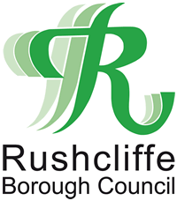

Application for National Non Domestic Rates Hardship Relief
The form can be returned to Freepost RTJY-BGGZ-EKZK, Rushcliffe Borough Council, Rushcliffe Arena, Rugby Road, West Bridgford, Nottingham, NG2 7YG.
This form can also be returned by email to the following address revenues@rushcliffe.gov.uk.
Please note you must also provide a completed state aid declaration form, which can be downloaded from our website.
Any business which is suffering hardship can claim for help with their rates.
Applications are considered on their individual merits and the following factors are taken into account, details of which should be provided overleaf.
- Evidence to show that it is the Business Rates that are causing the hardship.

- The effect the closure of the business would have on the community in terms of the loss of service provided to the council taxpayer

- The effect of unemployment if the business closed.

- The financial status of the person/organisation making the application (last three years' audited account must be included with any application for it to be considered).

Name of applicant.
Billing number.
Address of the property for which relief is being claimed.

Period relief is being claimed for.
Amount of relief being requested:

- Please detail the effect of unemployment in the Borough if the business closed:

- Please detail the effect the closure of the business would have on the local community in terms of the loss of service provided to the Council Taxpayer:

- Please explain how paying the Business Rates is causing hardship:

DECLARATION

I hereby certify that the information given in this form is correct to the best of my knowledge and belief.

Name of ratepayer.
Company number, (if applicable).
Name of person completing form.
Capacity of person completing form.
Telephone number.
Email address.

