I
N
G
F
R
I
E
N
D
L
R
E
A
S
T
F
E
E
D

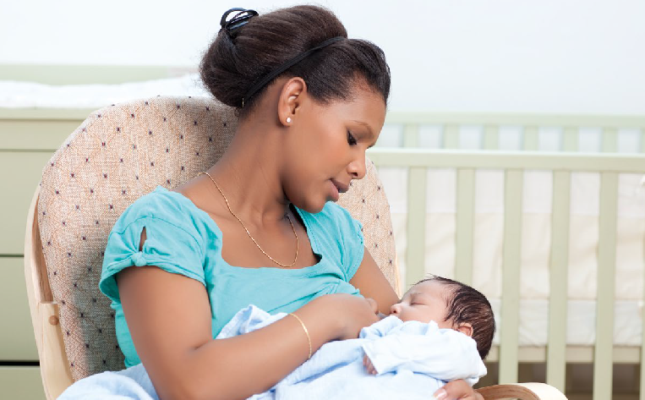
We’re encouraging businesses and venues within Nottinghamshire to provide more welcoming environments for breastfeeding mums by signing up to being ‘Breastfeeding Friendly’.
H
S
U
R
N
I
Y
B
E
F
F
I
L
C

We want
y Mums to be able to feed their baby in comfort and safety
y Mums to know where there are welcoming and supportive places for them to breastfeed
y To normalise breastfeeding in local communities.

Why become Breastfeeding Friendly?
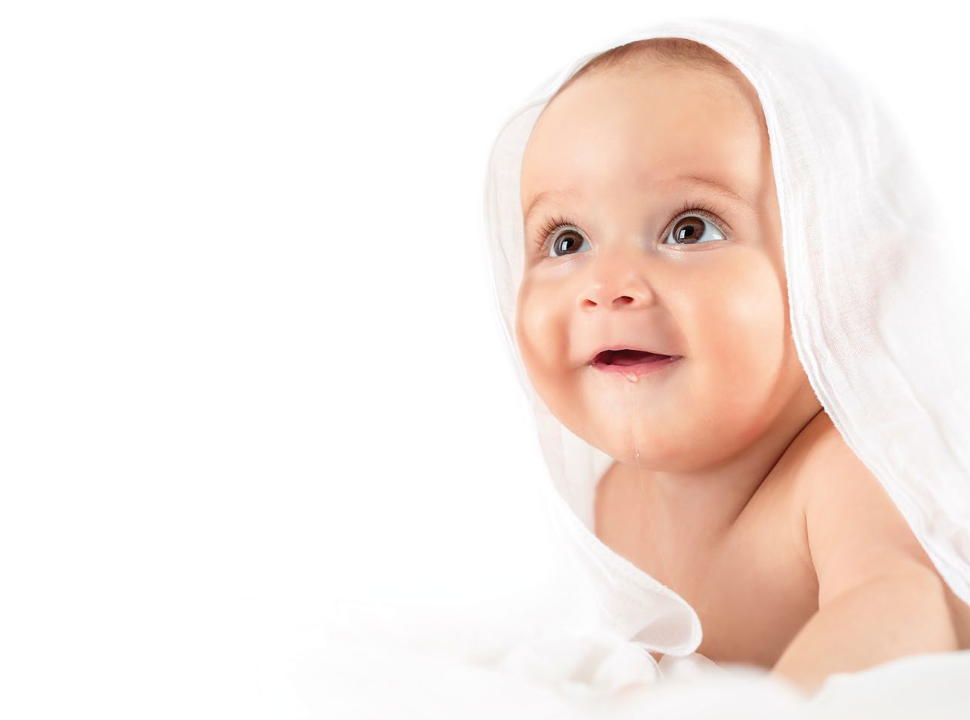
Improved customer service, and help attract and retain new customers
y Free positive publicity for little input
y You’ll be placed on our directory of Breastfeeding Friendly places, and receive Breastfeeding Friendly materials to display
y Supporting the health of your local community
y You’ll be compliant with the Equality Act 2010 which states that no breastfeeding mother can be discriminated against in public areas.

How to become Breastfeeding Friendly?

Do you…
y Allow breastfeeding in all public areas
y Provide breastfeeding mums with seating and a welcoming, clean and comfortable environment
y Employ staff that are positive towards and supportive of breastfeeding mums
y Understand that some mums prefer to feed in privacy, and help wherever you can

Would you …
y Ensure all appropriate staff have reviewed a short breastfeeding friendly training pack, including information about the law and breastfeeding in a public place
y Display a breastfeeding friendly sticker and certificate

…Then you can be Breastfeeding Friendly

Next steps
y You’ll start by completing a short self-assessment form
y You may then be visited to confirm whether your venue appears Breastfeeding Friendly (not all venues will receive a visit)
y We’ll provide you with simple information to help ensure all staff understand how to provide a welcoming environment - if needed we can provide more detailed support
y You’ll receive a certificate and stickers to display, and we’ll add your details to the Nottinghamshire Healthcare Trust directory of Breastfeeding Friendly places

For more information or to begin the self-assessment please contact
Sofi Melvin e: SMelvin@rushcliffe.gov.uk t: 0115 9148593

