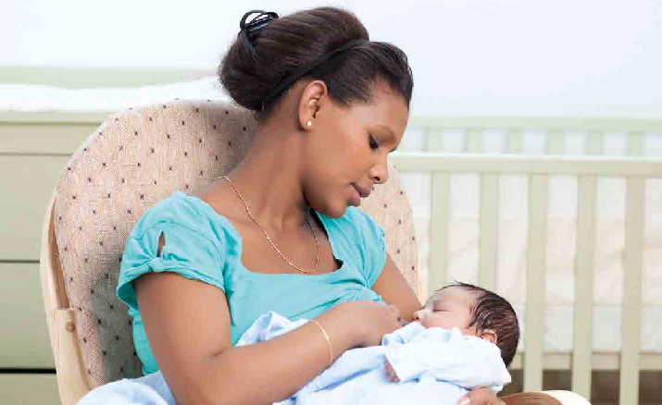
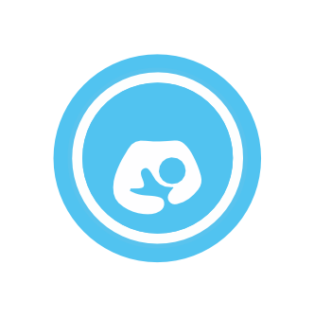
H
G
N
I

We understand some mums may prefer to feed in privacy, and we will help where we can, (This can be as simple as a chair positioned in a discreet corner of the room, or turned to face away from most people)

If you choose to provide a private room for breastfeeding, this will never be located within a toilet and will be a clean, comfortable environment with a chair that is appropriate for use by members of the public and clearly signposted
If we have a private room / area for breastfeeding:
y It is signposted
y It is not located in a toilet
y It has a chair

S
Breastfeeding Friendly places
U
R
N
I
L
Y
B
R
E
F
F
I
L
C

y We regularly check cleanliness
If food is prepared in our venue, we have a valid hygiene certificate at level 3 or above

We will clearly display the sticker and certificate to inform visitors that we are Breastfeeding Friendly

The next criteria is recommended for all venues, but essential for Local Authority and NHS premises We have baby changing facilities

We provide further facilities, or have some comments in support of our application:

Print name: Date:

N/A

self-assessment checklist
We want to help you work towards your organisation / venue becoming Breastfeeding Friendly and have included this handy checklist to help you meet the criteria required. If you’re unable to fully complete the checklist at this time, please don’t worry
- we’re here to help. Please contact us for help and advice on becoming Breastfeeding Friendly.
Sofi Melvin: e: SMelvin@rushcliffe.gov.uk t: 0115 9148593

Our aim is for:
y Mums to be able to feed their baby in comfort and safety
y Mums to know where there are welcoming and supportive places for them to breastfeed
y To normalise breastfeeding in our communities

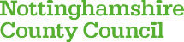
F
R
I
E
N
D
E
A
S
T
F
E
E
D
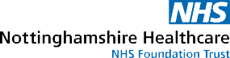

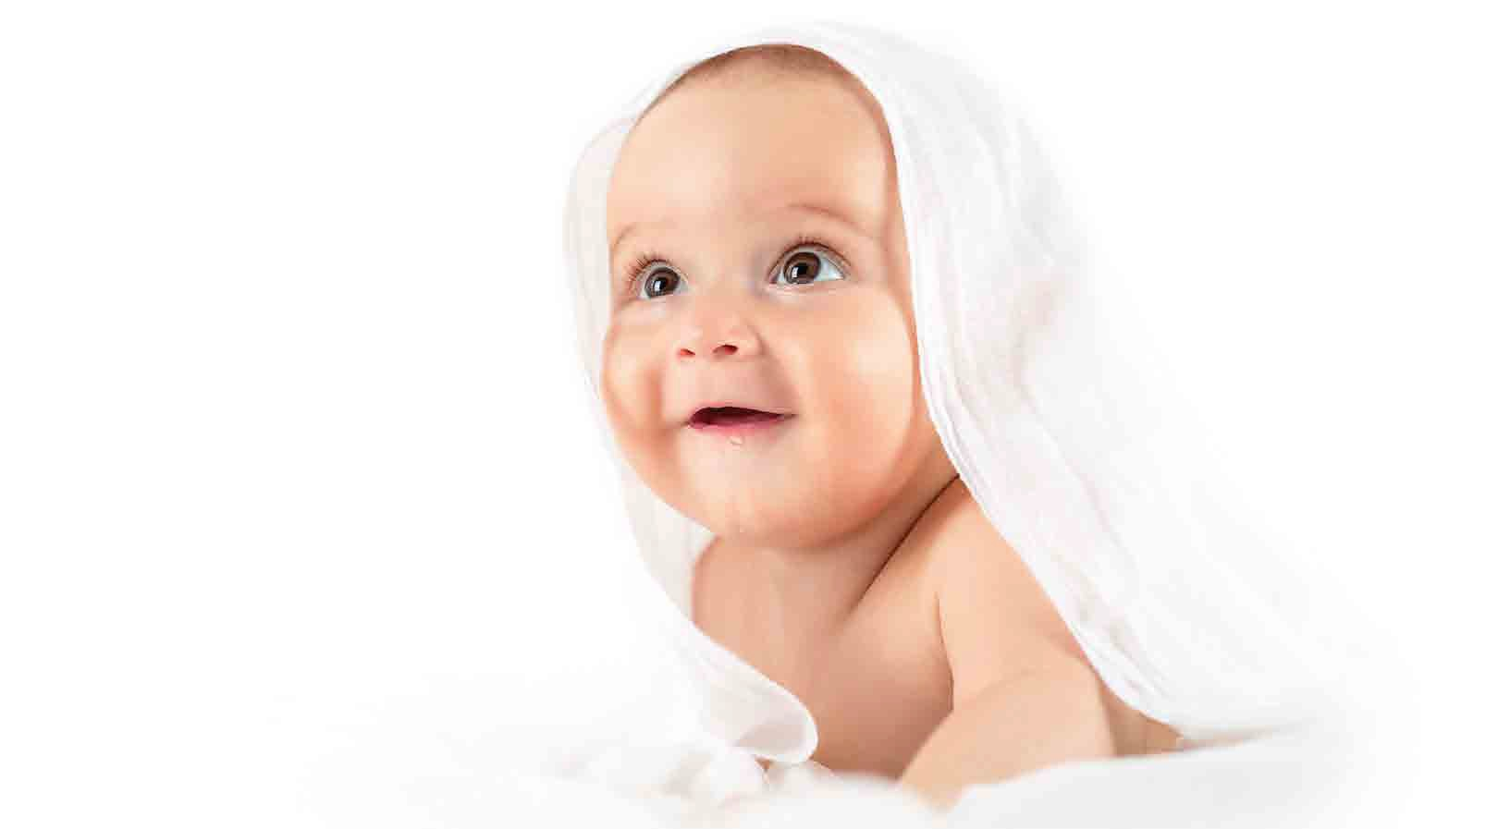
How to apply
Thank you for agreeing to become a Breastfeeding Friendly place. Once complete, your details will be added to our Breastfeeding Friendly directory, which can be viewed at www.nottinghamshirehealthcare.nhs.uk/breastfeeding- useful-information

Please complete this self-assessment and email a copy to
e: SMelvin@rushcliffe.gov.uk
We will review this carefully.

You may then be visited to confirm whether your venue appears Breastfeeding Friendly (not all venues will receive a visit).

We’ll then provide you with simple information to help ensure all staff understand how to provide a welcoming environment for breastfeeding women - if needed we can provide more detailed support.

You’ll receive a certificate and stickers to display, and we’ll add your details to the Nottinghamshire Healthcare Trust directory of Breastfeeding Friendly places.

The accreditation will last two years, following which time you should
re-apply to
Sofi Melvin e: SMelvin@rushcliffe.gov.uk

Re-application is easily arranged and should not take up much of your time.

Breastfeeding Friendly Self-Assessment
Contact Name: Organisation / Venue name:
Organisation / Venue type (short description) Address:

Post Code: Phone Number: Email Address of contact person:
We support breastfeeding in all public areas

We provide breastfeeding mums with seating and a welcoming, clean and comfortable environment
All our staff are positive towards and supportive of breastfeeding mums
In the event of a customer complaint, we explain why it’s important to support breastfeeding mums and invite the customer to move to another area, never mum and baby
All appropriate staff have reviewed the short Breastfeeding Friendly training package
We perform regular cleanliness checks

