I
N
G
F
R
I
E
N
D
L
Y
B
R
E
A
S
T
F
E
E
D

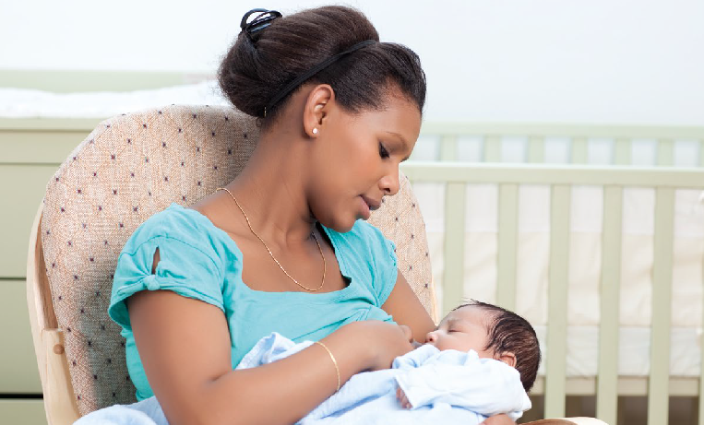
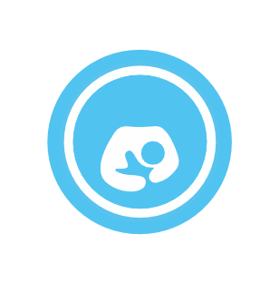
We’re encouraging businesses and venues within Nottinghamshire to provide more welcoming environments for breastfeeding mums by signing up to being ‘Breastfeeding Friendly’.
H
S
U
R
N
I
E
F
F
I
L
C

We want
y Mums to be able to feed their baby in comfort and safety
y Mums to know where there are welcoming and supportive places for them to breastfeed
y To normalise breastfeeding in local communities.

Why become Breastfeeding Friendly?
Breastfeeding improves the health of both Baby and Mum. Mums often cite fear of breastfeeding in public as a barrier to starting or continuing to breastfeed.

Breastfeeding
y Supports close and loving relationships which helps the baby’s brain development
y Provides antibodies, hormones and enzymes which work together to
help the baby grow and develop, and breastmilk is easier to digest for baby
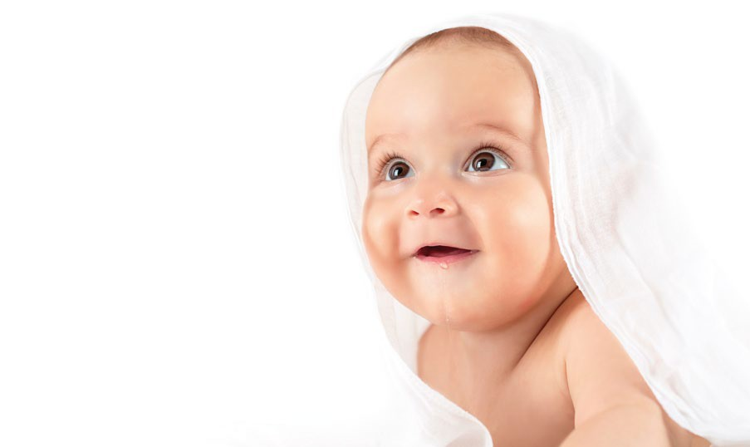
y Improves mental health and can lower the risk of post-natal depression
y Reduces mum’s risk of cardiovascular disease, osteoporosis and breast cancer
y Protects against ovarian cancer
y Has been linked to educational attainment
y Reduces the risk of Sudden Infant Death by 50%.

Not breastfeeding is linked to a higher risk of
y Being overweight or obese later in life
y Ear infections
y Tooth decay
y Chest infections
y Diarrhea & vomiting
y Death from gut infections in sick and premature babies.
How to become Breastfeeding Friendly?

Do you...
y Allow breastfeeding in all public areas
y Provide breastfeeding mums with seating and a welcoming, clean and comfortable environment
y Employ staff that are positive towards and supportive of breastfeeding mums
y Understand that some mums prefer to feed in privacy, and help wherever you can
y Have baby changing facilities

Would you...
y Ensure all appropriate staff have reviewed a short breastfeeding friendly training pack, including information about the law and breastfeeding in a public place
y Display a breastfeeding friendly sticker and certificate.
Then you can be Breastfeeding Friendly

Next steps
y You’ll start by completing a short self-assessment form
y You may then be visited to confirm whether your venue appears Breastfeeding Friendly (not all venues will receive a visit)
y We’ll provide you with simple information to help ensure all staff understand how to provide a welcoming environment - if needed we can provide more detailed support
y You’ll receive a certificate and stickers to display, and we’ll add your details to the Nottinghamshire Healthcare Trust directory of Breastfeeding Friendly places.

For more information or to begin the self-assessment please contact
Sofi Melvin e: SMelvin@rushcliffe.gov.uk t: 0115 9148593
