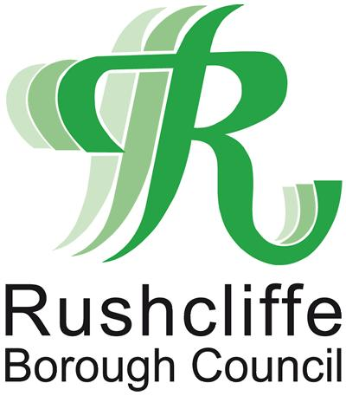
Rushcliffe Borough Council
Rushcliffe Arena, Rugby Road, West Bridgford, Nottingham, NG2 7YG
Telephone 0115 981 9911 and ask for Revenues Services
Website: www.rushcliffe.gov.uk Email: revenues@rushcliffe.gov.uk

Subsidy Declaration Form

Please read the information below before completing the form overleaf and returning it by post to Freepost RTJY-BGGZ-EKZK, Rushcliffe Borough Council, Rushcliffe Arena, Rugby Road, West Bridgford, Nottingham, NG2 7YG or by email to revenues@rushcliffe.gov.uk.

In general terms, and for the purposes of the UK’s international commitments, a subsidy is a measure which:

- is given by a public authority. This can be at any level – central, devolved, regional or local government or a public body;
- makes a contribution (this could be a financial or an in kind contribution) to an enterprise, conferring an economic advantage that is not available on market terms. Examples of a contribution are grants, loans at below market rate, or a loan guarantee at below market rate or allowing a company to use publicly owned office space rent free. An enterprise is anyone who puts goods or services on a market. An enterprise could be a government department or a charity if they are acting commercially; and
- affects international trade. This can be trade with any World Trade Organisation member or, more specifically, between the UK and a country with whom it has a Free Trade Agreement. For example, if the subsidy is going towards a good or a service which is traded between the UK and the EU this could affect trade between the EU and the UK. Please note that you are not being asked whether the subsidy could harm trade but merely whether there could be some sort of effect. Subsidies to truly local companies or a small tourist attraction are unlikely to be caught as this is unlikely to affect international trade.

The following is not a comprehensive list of the possible forms of subsidy. However, it should give an indication of the most common forms of subsidy, which you may have been given over the past three years. Potentially any assistance from a public body might be a subsidy. Should you have any doubts on this matter, please contact the body from which the assistance was received.

- Grants from public bodies
- Loans from public bodies at favourable rates
- Loan guarantees from public bodies
- Differential tax benefits
- Grants from an investment trust (including charities) which may themselves have received the funds from a public body
- Grants from a part publicly funded venture capital fund
- Publicly administered funds, even if the funds were originally not public such as the national lottery
- Waiving or deferral of fees or interest normally due to a public body such as the waiving or deferral of rent or waiver of interest normally due on late payment of taxation or other costs to a public body
- Monopoly licences or guarantees of market share
- Advertising via a public channel such as a tourist board or state owned television
- Consultancy advice provided either free or at a reduced rate
- Training provided either free or at a reduced rate
- Aid for investment in environmental projects
- Provision of a free or reduced rate feasibility study for research and development or other assistance with research and development
- Purchase of public land or property at a less than market rate
- Benefiting from the provision of infrastructure where your organisation was pre-identified as a beneficiary
You are being offered assistance in accordance with UK subsidy control guidelines. This allows a company or business to receive up to 325,000 Special Drawing Rights (currently approximately £353,000) of public subsidy over a rolling three-year period. The following requested information is a mandatory requirement to enable you to receive the support offered.

Name of ratepayer: __________________________________________________

Type of relief being claimed: __________________________________________________

Billing number: __________________________________________________

Please list below all subsidies received in the last 3 fiscal years:

Name of public authority who provided the subsidy | Subsidy scheme name | Date subsidy was awarded | Amount of subsidy received

Declaration

I declare that the information I have given on this form is correct to the best of my knowledge and belief.

Name of person completing form: _____________________________________________

Position in the company: _____________________________________________

Signed: _____________________________________________

Date: _____________________________________________

