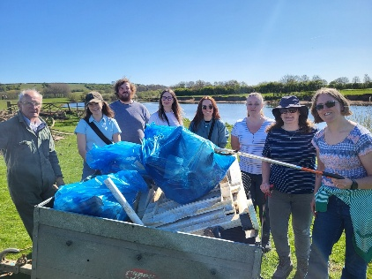
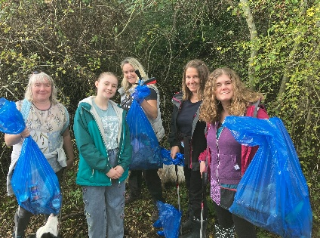
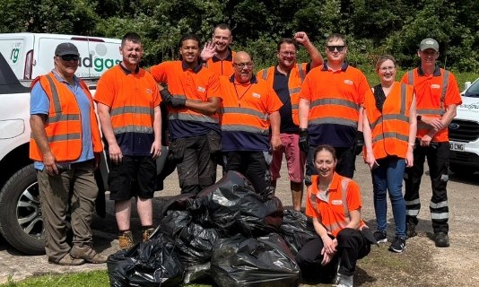
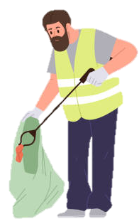
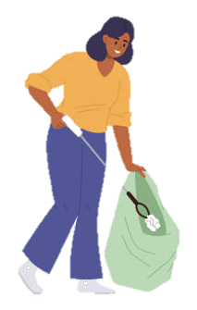
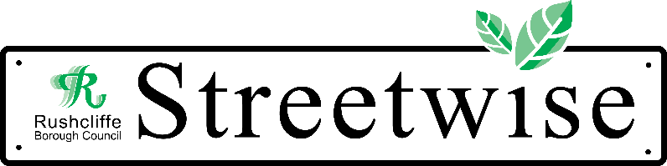
The Great British Spring Clean 2026 is almost here!
Friday 13th March – Sunday 29th March 2026
We are Spreading the word that the environment belongs to every one of us!
Litter Picking is a simple action that we can all do to make an immediate and drastic difference to our environment and places we live, work and play!

Want to join in on the national efforts and get involved in the Great British Spring Clean 2026?
Please get in touch!
We can help by providing Litter pickers, disposable gloves, hi-vis vest and bin bags!
Email: Streetwise@rushcliffe.gov.uk or Call: 01159819911
Please email us in your pictures of your litter picks!

Thank you for your support!
