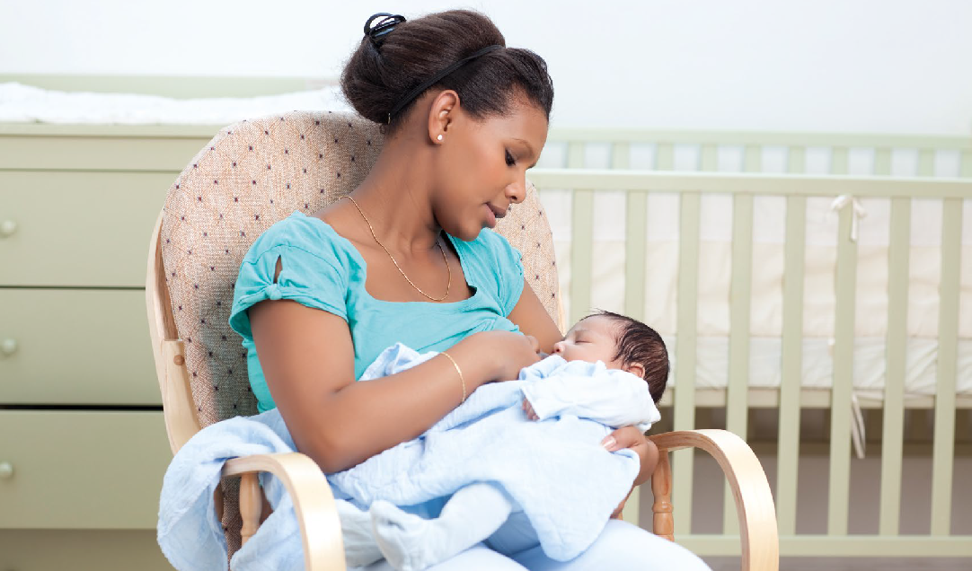
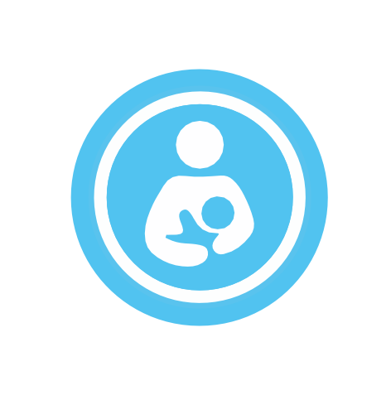
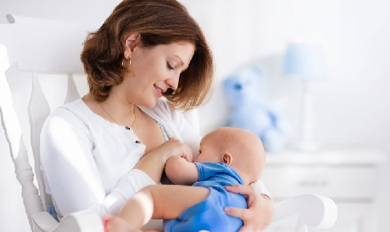
G
N
I
T
T
O
N
N
I
N
D
L
Y
B
R
E
A
E
R
I
H
S
M
A
H

Breastfeeding
Friendly
Resource pack

What is Breastfeeding Friendly?
- Breastfeeding Friendly facilities what should be provided?
- How to apply?
- Know the law – Equality Act 2010
- Supporting employees returning from maternity leave to continue to breastfeed
- Why is breastfeeding so important
- Training

I
N
G
F
R
I
E
S
T
F
E
E
D

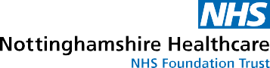

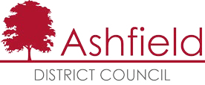
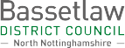
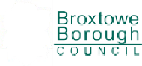
Mansfield
District Council

What is Breastfeeding Friendly
Nottinghamshire Healthcare NHS Trust, Nottinghamshire County Council, and all Nottinghamshire District and Borough Councils have launched a scheme to encourage businesses and venues within Nottinghamshire to sign up to being ‘Breastfeeding Friendly’ as part of action to provide a more welcoming and positive environment for breastfeeding mothers.
The Equality Act 2010 has specifically clarified that it is unlawful for a business to discriminate against a woman because she is breastfeeding a child.

We want
y Mums to be able to feed their baby in comfort and safety
y Mums to know where there are welcoming and supportive places for them to breastfeed
y To normalise breastfeeding in local communities
Organisations and venues that sign up to being Breastfeeding Friendly will be asked to adopt a positive breastfeeding friendly approach, including providing a welcoming, clean and comfortable environment for breastfeeding mums, and to ensure all staff are supportive of their needs.
Venues taking part will display stickers letting people know they are welcome to breastfeed, as well as a certificate.
Details of Breastfeeding Friendly venues will be available online via www.nottinghamshirehealthcare.nhs.uk/breastfeeding-useful-information. A range of support is available for breastfeeding women in Nottinghamshire which can also be found on this webpage.
District | Name | Email Address | Telephone Number

Ashfield |  | Tracey Bird,  Health& Wellbeing  Officer - Health Improvement | Tracey.bird@ashfield.gov.uk | 07514 648920
Bassetlaw |  | Sally Holden  Environmental Health | Environmental.health@bassetlaw.gov.uk | 01777 713764 or  01909 533219
Broxtowe |  | Alex Mcleish, Communities Officer (Health) | Alex.Mcleish@broxtowe.gov.uk | 0115 917 3431
Gedling |  | Fiona Hextall,  Sports and Health Development Officer – Community Relations | Community@gedling.gov.uk | 0115 901 3635  07813 778591
Mansfield |  | Sandra Alvey, Healthy Lifestyles Officer | leisuredevelopment@mansfield.gov.uk | 01623 463470
Newark and Sherwood |  | Alison Hardman Health Improvement Officer | Alison.Hardman@newark-sherwooddc.gov.uk | 01636 655855
Rushcliffe |  | Sofi Melvin, Health Development Officer | SMelvin@rushcliffe.gov.uk | 0115 9148593
County libraries |  | Andrea Lowe  District Manager – Gedling, Rushcliffe & Mansfield Central Libraries | Andrea.lowe@inspireculture.org.uk | 07768 536631

Breastfeeding Friendly
facilities what should be provided

All Breastfeeding Friendly venues should meet these requirements:
We support breastfeeding in all public areas We provide a welcoming environment for
all breastfeeding feeding mums, including seating and a clean and comfortable environment. All our staff are positive towards and supportive of breastfeeding mums.
In the event of a customer complaint, we will explain why it’s important to support
breastfeeding mums and invite the customer to move to another area, never mum and baby.
All appropriate staff have reviewed the short breastfeeding friendly training package.
We perform regular cleanliness checks.
We understand some mums may prefer to feed in privacy, and we will help where we can.
This can be as simple as a chair positioned in a discreet corner of the room, or turned to face away from most people.
If you choose to provide a private room for breastfeeding, this will never be located within a toilet and will be a clean, comfortable environment with a chair that is appropriate for use by members of the public and clearly signposted.
If we have a private room / area for breastfeeding:

y It is signposted
y It is not located in a toilet
y It has a chair
y We regularly check cleanliness.
If food is prepared in our venue, we have a valid hygiene certificate, at level 3 or above.
We will clearly display the sticker and certificate to inform visitors that we are Breastfeeding Friendly.
Recommended for all venues, but essential for District/Borough/Council and NHS premises We have baby changing facilities.

How to apply
Contact the named link at your district council who will send you a self-assessment to complete. Once you have completed this, the self-assessment will be reviewed by a breastfeeding support worker.
Once you have achieved the Breastfeeding Friendly status, you will be sent a certificate and sticker to display. You will be sent relevant breastfeeding information and any changes to enable you to continue to provide effective support to breastfeeding mothers.
You may then be visited by a local breastfeeding mother or breastfeeding support volunteer, who will confirm whether your venue appears Breastfeeding Friendly. Not all venues will receive this visit.
If, after a visit, the venue doesn’t yet meet the requirements of Breastfeeding Friendly we will work with you to make any necessary changes to maintain accreditation, however there may be occasions where accreditation is removed.
The accreditation will last two years, following which time you should re-apply to complete the self-assessment via your district council. The re-application is simple and should not take up much of your time.

Know the law Equality Act 2010

Equality Act 2010: Breastfeeding mothers
A business cannot discriminate against mothers who are breastfeeding a child of any age.
The Equality Act 2010 has specifically clarified that it is unlawful for a business to discriminate against a woman because she is breastfeeding a child.
A business may ask a breastfeeding woman to leave their premises if the reason for this request is not due to her breastfeeding. However, if the woman later claims that discrimination occurred because she was breastfeeding, the business will have to prove that there was in fact no discrimination.
DO make sure women you’re providing services to are supported to breastfeed on your premises if they want to.
DO ensure that mothers breastfeeding babies are not discriminated against, no matter how old the baby is.
DO train all your employees, especially those who deal with the public, to be aware of the protection from discrimination given to breastfeeding mothers under the Equality Act 2010.
DON’T forget, under the Equality Act 2010, discriminating against someone because they are with a breastfeeding mother is also prohibited, so companions of breastfeeding mothers who are also treated unfairly may have a claim too.

Examples
Saul, a bus driver, tells Kate, who is breastfeeding on the bus, that if she does not either stop or get off the bus she could be arrested for indecency. This is not only inaccurate, but it is unlawful direct discrimination, and the company will be liable under the Equality Act 2010 unless it can show that it has taken all reasonable steps to stop the driver from acting in this way. Saul will be liable whether or not his employer is.
Anne is in a café owned by Chris. Anne is swearing loudly at her partner, Bob, while breastfeeding her child. Chris asks Anne to talk more quietly or to leave. Anne and Bob leave and they decide to claim that this was discrimination because Anne was breastfeeding. But because the reason why they left was unconnected to Anne breastfeeding, this would not amount to unlawful discrimination.

Frequently asked questions - the Equality Act and breastfeeding.
Am I responsible for how other customers treat a woman who is breastfeeding?
Yes, you may be responsible, and you will be responsible if other customers’ behaviour has been brought to your attention and you failed to act. You have an obligation to ensure that a woman who is breastfeeding while receiving a service you provide is not treated unfairly. The Equality Act 2010 aims to give women complete confidence to breastfeed while going about their day-to-day business. Businesses must facilitate this.

Does this mean I have to create a separate facility to allow women customers to breastfeed?
No, but you are under an obligation to ensure that a woman can breastfeed without being treated unfairly. It is up to you to decide how best to do this, a private space is not required.

For further information on the Equality Act please visit: www.legislation.ov.uk/ukpga/2010/15/contents

Supporting employees returning
from maternity leave to continue to breastfeed
Breastfeeding can be a sensitive issue for employees to discuss with their line manager, but it is an important part of transition back to work after maternity leave.
You organisation should develop guidance to support employees to continue breastfeeding when they return to work, this should include:

y Flexible breaks for expression
y Clean, warm and private places to express
y Safe storage
y Flexible working hours
y Risk assessment
Your organisation should value breastfeeding and its significant health benefits for both mother and baby. Prior to return to work a discussion should take place about the arrangements that will be made to support continuation of breastfeeding. This will usually be facilities to support
expressing and storage of milk (refrigerator) whilst at work as well additional or flexible breaks for expression. Other arrangements to continue breastfeeding may also be made.
To support women to continue expressing, a private space with a chair and electric point is usually required, there should be access to hand and equipment washing facilities, and a toilet will never be proposed as a suitable space. It’s unlikely that the private space would be exclusively used for this purpose.
We suggest that a line manager and employee should discuss what would be most appropriate and periodically review arrangements made.
We suggest that expressed milk should always be clearly labelled as breastmilk with name, time and date displayed and placed in a clean sealed bag or box before placing in the fridge for storage.
We may be able to support you further to develop this guidance, please contact us for further advice. (See page 2 for details).

Why is breastfeeding so important

The UK government recommends exclusive breastfeeding for around 6 months.
The below is a snap shot of rates of any breastfeeding at 6 months (not just exclusive breastfeeding):
y Senegal – 99% y Norway – 71% y US – 49%

y UK – 34%
As you can see the UK is much further behind other countries. Eight out of ten women stop breastfeeding before they want to and say they could have continued with more support.
Many English mothers feel that breastfeeding is not acceptable in public, mums often tell us that fear of breastfeeding in public is a barrier to them either starting or continuing to breastfeed. We want to change this, and by being part of Breastfeeding Friendly Nottinghamshire, and spreading the word, you can help us.

Breastfeeding is important because it improves the health of both baby and mum.
Breastfeeding:
y supports close and loving relationships which helps the baby’s brain development, helping baby with emotional, social, physical and cognitive skills
y improves mental health and can lower the risk of post-natal depression
y aids the growth and development of the baby’s gut
y destroys bacteria, and reduces the risk of infections such as gastroenteritis, ear, urine and chest infections, illnesses such as diabetes and childhood leukaemia,
y reduces the risk of Sudden Infant Death syndrome
y Breast milk is packed full of antibodies, hormones and enzymes which work together to help the baby grow and develop, and is easier to digest for baby
y has been linked to educational attainment

Training  We have developed a simple training pack for each area of Nottinghamshire. We ask that you ensure key staff (those who are most likely to come into contact with breastfeeding women, and their managers, as well as the person who is responsible for implementing Breastfeeding Friendly) | y reduces obesity in later life  y provides less waste and less strain on the NHS  y lowers mum’s risk the risk of breast cancer, cardiovascular disease and osteoporosis  y protects against ovarian cancer
review this.
You can use this in the way that best suits your organisation - delivering a short session on it, asking people to read through it alone, or using it as part of a team meeting - whichever way you choose we ask you to confirm that this has been completed as part of the self- assessment process.
You can access a copy of this by emailing your named link in section one of this guide.

