Vacation Notification
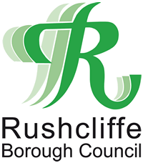
The form can be returned to Freepost RTJY-BGGZ-EKZK, Rushcliffe Borough Council, Rushcliffe Arena, Rugby Road, West Bridgford, Nottingham, NG2 7YG.
This form can also be returned by email to the following address revenues@rushcliffe.gov.uk.

Nate of Ratepayer vacating.
Billing Number.
Address of the property being vacated.

Date of property became unoccupied? (Please note this is the date both personnel and stock were removed).
Address for future correspondence.

Date lease ends, (if applicable).
Date property sold, (if applicable).
Name and address of owner following vacation?

DECLARATION

I hereby certify that the information given in this form is correct to the best of my knowledge and belief.

Name of ratepayer.
Company number, (if applicable).
Name of person completing form.
Capacity of person completing form.
Telephone number.
Email address.

