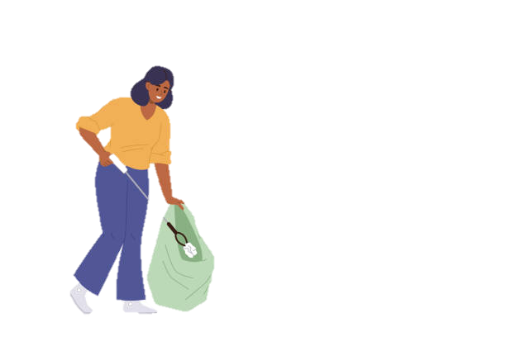
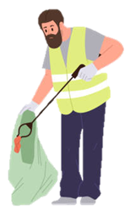
Litter Picking Volunteer Health and Safety Guidelines

Thank you for volunteering with us, we really value your support. Whilst you are litter picking in the borough, please ensure that you follow the below guidance to stay safe! Remember you have a responsibility to keep yourself and those with you free from harm and not put them at risk. If you have children with you, you are responsible for their safety.

- To carry out litter picking safely please always wear the high visibility vest and gloves provided. Always use the litter picker, do not pick up any litter with your hands.

- Consider the weather and wear appropriate clothing. For example, if it’s sunny wear a hat and use sunscreen. Wear clothing to protect your arms and legs from brambles/nettles. Always wear sensible footwear, not sandals.

- Consider any dangers from the area where picking. Please do not litter pick near busy roads, water courses or in secluded or dark areas. Remember to let others know where you are and have the means to raise the alarm in an emergency.

- Do not kneel or lean on an area of ground that has not been litter picked.

- Handle all litter with care - be observant as there could be sharp or dangerous objects concealed in waste piles.

- Please do not attempt to clear hazardous waste such as dog fouling, drug paraphernalia, glass or needles, or suspected asbestos material. Please report these directly to us on the Rushcliffe Borough Council website - Contact Details | Litter |

- Replace waste bags regularly and do not attempt to lift any heavy waste. Larger fly tipped waste items must be reported on the Rushcliffe Borough Council website - Contact Details | Fly Tipping |

- When handling bagged waste, consider how it is handled. Always hold the bag away from your legs and body to minimise the risk of injury from sharp objects. Never carry bags over your shoulder.

- When you have filled a bag, tie it securely. Bags should be left in clearly visible piles in an accessible area such as by public bin or bus stop to allow for our teams to remove and dispose of them. Please report any bags to be collected – Streetwise@rushcliffe.gov.uk

- Always be mindful of your own limitations. Do not overexert yourself – change position frequently when you are litter picking and change hands. Varying your position will put less strain on your back.

If you have any questions or need further information at all, please do not hesitate to contact us at Streetwise@rushcliffe.gov.uk

Operational Hazards Risk Asessement

 | High |  | Medium |  | Low

Hazard | Associated Harm | Control Measures | Risk Severity
Hazard | Associated Harm | Control Measures | Without Controls | With Controls
Sharp objects (glass, metal) | Cuts, lacerations, puncture wounds, blood-borne infection | Use litter pickers; wear gloves; visually assess area before collecting;
Hazardous waste (needles, drugs paraphernalia, chemicals,  dog fouling) | Needlestick injuries, contamination, exposure to bodily fluids, chemical irritation/burns | Do not pick up; report to Streetwise; cordon off area if necessary.
Slips, trips and falls | Sprains, strains, fractures, bruising | Wear suitable footwear; avoid uneven, wet, or unstable ground; maintain good situational awareness.
Proximity to roads / traffic | Vehicle impact, near-miss incidents, collision injuries | Do not litter-pick near busy roads; maintain safe distance; avoid high-speed routes; use hi-vis PPE.
Litter along roads / verge edges | Vehicle strike, loss of footing near road edge, near-miss incidents | Keep well away from active traffic lanes; avoid fast roads; maintain awareness; use hi-vis PPE.
Weather exposure (hot, cold, wet) | Heat exhaustion, dehydration, sunburn, hypothermia | Wear suitable clothing; apply sunscreen; stay hydrated; take breaks; avoid extreme weather.
Manual handling of bags or equipment | Muscle strain, back injury, soft-tissue damage | Avoid heavy lifting; do not overfill bags; use correct posture; carry bags away from body.
Hidden objects in vegetation | Cuts, abrasions, insect stings, skin irritation | Wear long sleeves/trousers; use picker to probe vegetation; avoid dense or hazardous growth.
Lone working | Delay in emergency response, inability to summon assistance | Tell someone location; carry phone.
Collecting empty drug canisters | Exposure to chemical residue, contamination, respiratory irritation | Do not collect; avoid touching; maintain distance; report to Streetwise for safe removal.

