
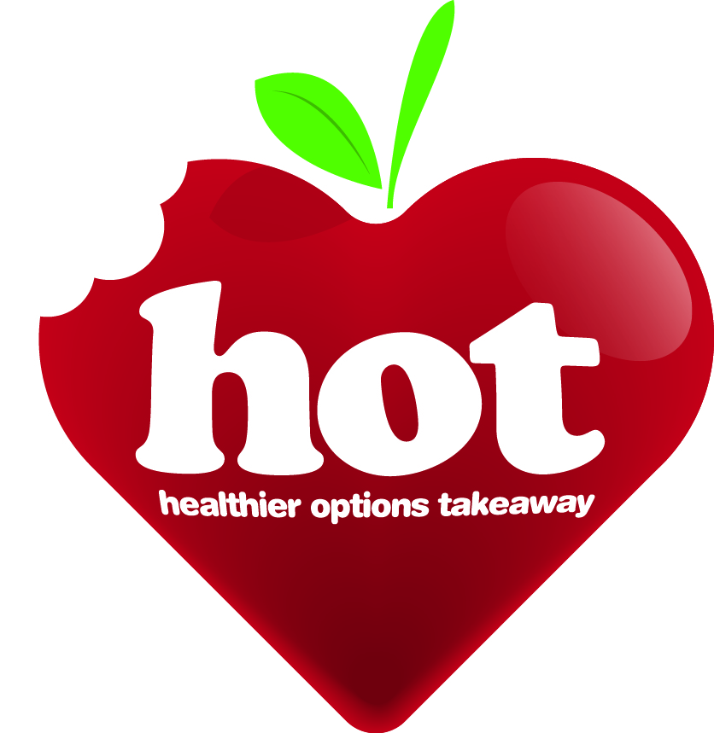

Healthier Options Takeaway (HOT) self-assessment form guidance

- A HOT merit can only be awarded to businesses that have a Food Hygiene Rating of 3 or above.
- The HOT merit assessment is made up of six categories. Takeaways must answer every question, provide evidence or comments, and make three pledges that propose actions and changes to improve healthier choices.
- Takeaways must score 34 out of a potential 56 (60%) to gain a HOT merit.
- Answers scored not applicable (N/A) may need to be reviewed and could be used in pledges or expanded on in other areas or comments.

Questions and examples/guidance | N/A guidance | Yes  score | No  score | N/A  score
1. Displays, pricing, promotion and training
1a  e.g. sugar free/reduced sugar drinks | Should be applicable to all | 2 | 0 | 0
1b | Should be applicable to all | 2 | 0 | 0
1c  If “No” please comment if you would take up the opportunity for staff to attend a short training session if was offered as part of the merit |  | 2 | 0 | 0
1d | Should be applicable to all | 2 | 0 | 0
1e | Should be applicable to all | 2 | 0 | 0

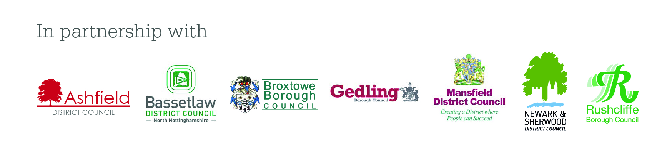
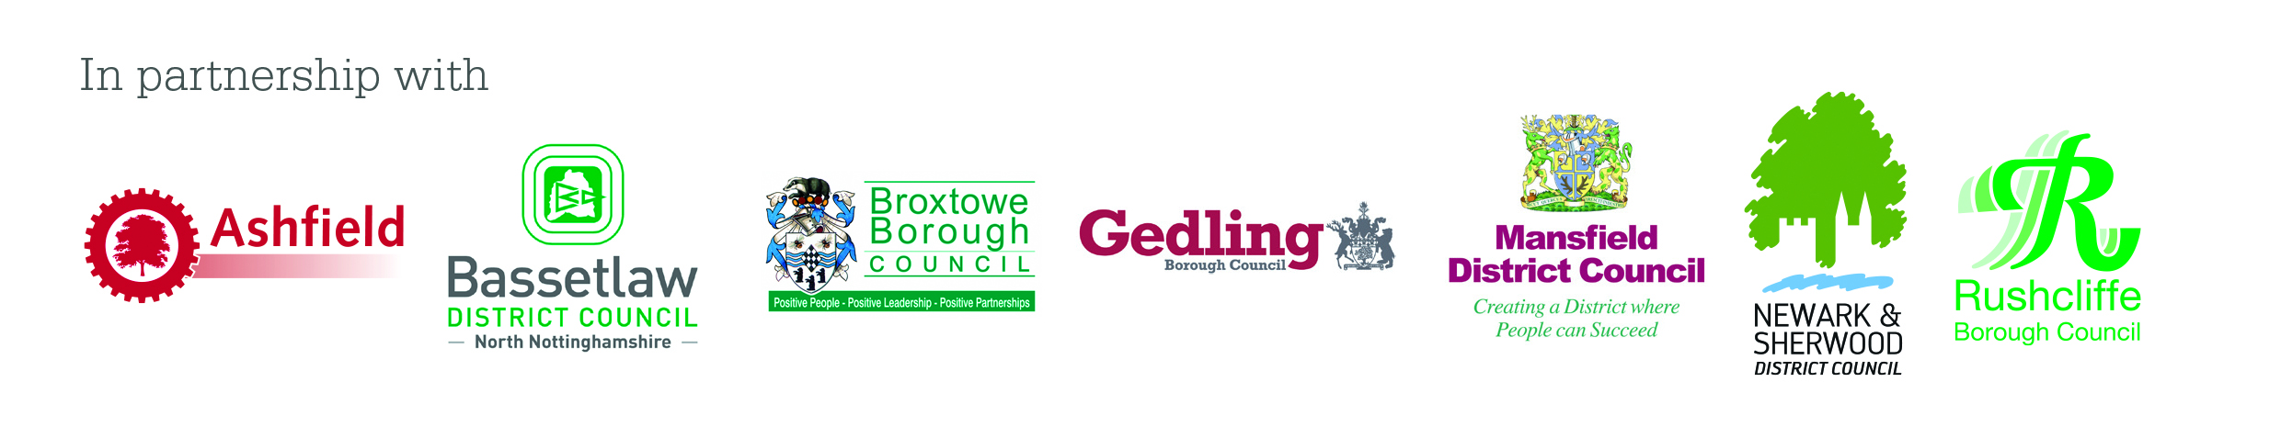
2. Fruit and vegetables (not including potatoes)
2a  100% pure unsweetened fruit juice, not from concentrate |  | 2 | 0 | 0
2b | Should not be N/A if there are vegetables served as part of main meals | 2 | 0 | 0
2c  E.g. vegetable toppings on pizza, more vegetables added to curries/stir fry dishes, salads, boiled/steamed peas with fish and chips (not mushy) | Should be applicable to all | 2 | 0 | 0
2d  E.g. beans, peas (boiled), salad, piece of fruit |  | 2 | 0 | 0
3. Potatoes, bread, rice, pasta and other starchy carbohydrates
3a  Bread, rice, pasta, pitta, chapatti etc. | Only N/A if do not sell starchy foods (bread, rice or pasta) | 2 | 0 | 1
3b  Thick cut chips absorb less fat. Make your chips using a cutter with at least a 14mm (just over ½ inch) cross section | Only N/A if do not serve chips | 2 | 0 | 1
3c  E.g. baked potato or potato wedges | Only N/A if fried potato options are not offered | 2 | 0 | 1
3d  E.g. baked, steamed or boiled | Only N/A if do not sell a rice option | 2 | 0 | 1
4. Dairy and alternatives.
4a  E.g. semi skimmed/skimmed milk or low fat yoghurt | Only N/A if do not cook with dairy | 2 | 0 | 1
4b  E.g. with takeaway drinks, yoghurts or accompaniments | Only N/A if do not sell takeaway dairy products or hot drinks | 2 | 0 | 1
4c  E.g. mozzarella, feta, half fat cheese ( <20% fat | N/A if do not cook with cheese, or use cheese as a filling | 2 | 0 | 1
5. Beans, pulses, fish, eggs, meat and other proteins.
5a | N/A if the business does not serve meat or meat products | 2 | 0 | 1
5b | N/A if the business does not serve meat or fish | 2 | 0 | 1
5c | N/A if do not cook meat or meat products | 2 | 0 | 1
5d  E.g. in curry or stir-fry dishes | N/A if do not sell traditional meat dishes | 2 | 1 | 1
6. Fats, sugar and salt
6a  E.g. margarine, sunflower, corn or rapeseed oil instead of saturated fats such as lard, palm oil, ghee, butter  Offering a low fat margarine for sandwiches or jacket potatoes or no butter/margarine. | Should be applicable to all | 2 | 0 | 0
6b  E.g. sunflower, corn or rapeseed oil instead of saturated fats such as lard, palm oil, ghee, butter  The more saturated fat in your oil, the more saturated fat there will be in your food. | Should be applicable to all | 2 | 0 | 0
6c  Check the manufacturer’s instructions for the correct use of your specific equipment | N/A if do not deep fat fry | 2 | 0 | 2
6d  Shake the chips, bang the basket vigorously twice and hang for at least 20 seconds | Only N/A if don’t cook or have a drain fat option | 2 | 0 | 1
6e  E.g. diet coke/Pepsi etc.  Prominently display these drinks in fridges at eye level. Put the high sugar drinks out of eye level | Should be applicable to all | 2 | 0 | 0
6f  E.g. chips, baked potatoes, sandwiches  Give limited number of salt sachets per meal | Should be applicable to all | 2 | 0 | 0
6g | Should be applicable to all | 0 | 2 | 0
6h | Should be applicable to all | 0 | 2 | 0

Definitions

Fat free | The item must contain no more than 0.5g of fat per 100g or 100ml
Ingredients | Basic items used in cooking a meal, this could include stocks, sauces or dressings
Lean minced meat | A fat content of 7% or less
Low fat | Low fat the item must contain no more than 3g of fat per 100g for solids or 1.5g of fat per 100ml for liquids
Low salt/sodium | The item must contain no more than 0.3g salt/ 0.12g of sodium, per 100g or per 100ml.  For waters, other than natural mineral waters falling within the scope of Directive 80/777/EEC, this value should not exceed 2mg of sodium per 100ml.
Low sugar | The item must contain no more than 5g of sugars per 100g for solids or 2.5g of sugars per 100ml for liquids
Menu items | Items which can be selected from the menu rather than being incorporated into a prepared meal. This could include sausages or breakfast cereals
Non processed | Vegetables and salads with nothing added including salt, brine, oil or dressings
Offer | That the business will promote the availability of the healthier option and provide it to the customer on request
Preparation | Assembling a variety of ingredients to create a meal
Promote | in writing, customer facing, in a prominent position
Sugar free | The item must contain no more than 0.5g of sugars per 100g or 100ml
Wheatgerm | bread that has at least 10% wheatgerm added
Wholegrain | A product, such as pasta, described on the label as wholewheat (or other grain)
Wholemeal bread | bread made with only wholemeal flour

