Nottinghamshire’s Hygiene Accreditation Scheme
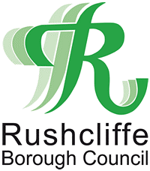
Application Form

In accordance with the scheme rules, proprietors have the opportunity to request assistance from the Local Authority before the initial inspection to facilitate compliance with the rating schedule.

Proprietors are encouraged to seek assistance from Local Authorities and implement practices required by the schedules in advance of the initial inspection.

For this reason, proprietors should allow sufficient time before submitting the application to the Local Authority.

Premises Details
Name of premises:

Address:

Postcode:

Telephone Number:

Emails:

Activities:  (please tick all appropriate boxes) | Tattooing  Semi-Permanent Make-up  Cosmetic Piercing

Proprietor/Applicant Details
Name of proprietor:

Position in the Business:

DECLARATION

- I confirm that the information contained within this application is true and has been completed by the Proprietor.
- I confirm that I have read and understand the rules of the Hygiene Accreditation Scheme (including the condition of entry, membership requirements, process for re-rating and the process for withdrawal etc).
- I acknowledge that the certificate/window sticker and any similar materials remain the property of the Local Authority and must be returned upon demand.
- I consent to the Local Authority retaining this application and details on its database(s).

Signed:

Date:

Please return this form by email to licensing@rushcliffe.gov.uk. or to:

Environmental Health, Rushcliffe Borough Council, Rushcliffe Arena, Rugby Road, West Bridgford, Nottingham, NG2 7YG

Upon receipt of this form, an officer will contact you to arrange for the payment of the fee.

