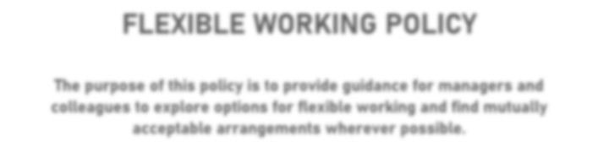
Smoke Free Policy
Smoking is the biggest cause of preventable death and illness in the UK. Every year, around 78,000 people die from smoking, with many more deaths caused by smoking-related illnesses.
People who breathe in secondhand smoke are at risk of getting the same health conditions as smokers, particularly lung cancer and heart disease. For example, breathing in secondhand smoke increases a non-smoker's risk of developing lung cancer or heart disease by about 25%.

Contents
1.0 Principles 2
Relevant forms and letters:

Related policies/guidance:

- Workplace Health pages on the Intranet

Staff Wellbeing

2.0 Scope 2
3.0 Legislation 2
4.0 Roles and Responsibilities 3
5.0 Further Advice 3
6.0 Policy Changes/Review 3

If you have any questions about this policy, or require any further support, please contact the HR Team on 0115 914 8289 or by email to hr@rushcliffe.gov.uk

Please note:

- This policy applies to all employees within Rushcliffe Borough Council unless stated otherwise within the policy.
- This policy does not form part of contracts of employment.
- Rushcliffe Borough Council reserves the right to amend this policy from time to time.

- Principles

  - The following policy has been adopted by Rushcliffe Borough Council (‘the Council’) to comply with legislative requirements and take all reasonable steps to protect employees from second-hand smoke exposure whilst also seeking to support those employees who wish to give up smoking. Smoking is prohibited on premises owned, shared or controlled by the Council including entrances to premises and car parks.
  - Smoking is prohibited in all Council owned vehicles. This requirement also extends to all vehicles that are being used on Council business, and are carrying a passenger(s)
  - The sale of tobacco will be prohibited in all Rushcliffe Borough Council Premises.

- Scope

2.1 This policy applies to all employees whether employed directly by the Council, through an agency, by a contractor or other organisation, elected members and visitors.
2.2 The policy includes Council owned hostels apart from residential bedrooms which may be designated as smoking rooms for residents if they are totally enclosed and provided with ventilation.
2.3 This policy applies to the use of electronic cigarettes (e-cigarettes). The use of e-cigarettes or vaping devices is prohibited wherever smoking is prohibited

- Legislation

3.1 Section 2(2) of the Health and Safety at Work Etc. Act 1974 places a duty on employers to:
Provide and maintain a safe working environment which is, so far as is reasonably practical, safe, without risk to health and adequate as regards to facilities and arrangements for welfare at work.

3.2 In addition the regulations made under the Health Act 2006 prohibit smoking in virtually all enclosed public places and workplaces (including vehicles) which came into force on 1 July 2007.

4.0 Roles and Responsibilities

4.1 Line managers will be responsible for the promotion and maintenance of the policy by their staff. Advice and guidance is available from Human Resources in relation to compliance and enforcement responsibilities under the policy.
4.2 Employees should inform the appropriate line manager of anyone who fails to comply with the policy.
4.3 Visitors not adhering to the policy will be asked to comply or leave the premises.
4.4 The Council recognises that smoking is an addiction and wishes to support employees who want to stop. Therefore to support smokers wanting to stop smoking, the Council will help with funding of an appropriate nicotine replacement therapy for any employee.
4.5 Employees should be referred by their line manager to Human Resources who will coordinate with the Health Development Officer appropriate smoking cessation support and or information on free local stop smoking services.
4.6 Job applicants will be made aware of the policy via application packs and a copy of the policy will form part of new employees’ induction packs.
5.0 Further Advice

5.1 The Council is concerned with protecting employees’ exposure to the harmful effects of second-hand smoke. Although domestic and social settings fall outside the remit of this policy, Human Resources will be able to support with signposting to information on how to protect yourself and your family from second-hand smoke at home and in the wider community.
5.2 To support colleague’s awareness of local smoking cessation support, the council will participate in regular promotion through the Workplace Health Champions.
6.0 Policy Changes/Review

6.1 This policy is subject to change due to legislative or organisation requirements. Significant organisational requirement changes to this policy will be made in conjunction with Trade Union officials as per standard process.

